Solar Powered Battery Charging System with
Maximum Power Point Tracking
A Project Report
Submitted in the Partial Fulfilment
Of the Requirements for the degree of Bachelor of Technology (ELECTRICAL ENGINEERING)

Submitted by:
MINAL RAJ (18BEE0169)
AYUSH NEGI (18BEE0148)

Under the guidance of

DR. Saravanan B
ELECTRICAL ENGINEERING DEPARTMENT
VELLORE INSTITUTE OF TECHNOLOGY, VELLORE
MAY 2021
UNDERTAKING

We declare that this written report submission represents our original ideas in our own words and wherever others' ideas or words have been included, we have properly cited and referenced the corresponding original sources. We also declare that we have adhered to all the principles of academic honesty and integrity and have not misrepresented or fabricated or falsified any idea, data, fact or source in our submission. We understand that any violation of the above will be cause for disciplinary action by the Institute and can also evoke penal action from the sources which have thus not been properly cited or from whom proper permission has not been taken where needed.

May, 2021

Vellore

Minal Raj Ayush Negi

A PV system require legitimate battery charge controller to adjust the power flow from PV system to battery and load such that photovoltaic control is utilized viably.

In this buck boost regulator is used to controls the charging process of battery. MATLAB/Simulink model is used to analyze the converter, modal evaluation and parameter extraction. This is a stand-alone system with Perturb and Observe(P&O) MPPT algorithm and can be used for stand-alone application. Single ended primary inductor converter (SEPIC) is used to match the impedance of solar panel and battery to deliver maximum power. Voltage and current from the solar panel is sensed and duty cycle of gating signal is varied accordingly by the algorithm to attain maximum power transfer.
TABLE OF CONTENTS ABSTRACT
INTRODUCTION

LITERATURE SURVEY

1. Solar PV Model
2. Solar Array Parameter
3. Specification of JINKO Solar PV
4. Standard Test Conditions for Specifying solar PV module
5. Types of PV System
6. Advantages of Solar Battery Charger
7. Challenges in Solar Battery Charger
8. Solar Battery Features
9. Battery Standards

METHODOLOGY

CONCLUSION

REFERENCES
Introduction

• Natural resources such as coal, oil and natural gas are intensely depended on to produce energy in the world. But with the current rate of energy consumption fossil fuels may be drastically depleting and hence leading to future crisis.
• To tackle this problem and to reduce the usage of fossil fuels, use of renewable energy must be encouraged.
• Among all the renewable energies solar energy is one of abundant energy available on earth. This photovoltaic power is harnessed by converting irradiance into electricity using solar panels.
• The world’s total installed PV capacity reached approx. 627 GW at the end of December 2019, according to the latest statistics published by IRENA (International renewable energy agency).

• Asia is the region with largest share of cumulative PV capacity, with around
274.6 GW followed by Europe and North America with 119.3 GW and 55.3
GW respectively.

• India has a good level of solar radiation, receiving the solar energy equivalent to more than 5000 trillion kWh/yr.

• Currently, India has the fifth highest solar installed capacity in the world with installed capacity of 24.33 GW as recorded on October 2018.

• The global and Indian trend for PV installed capacity is provided in figure 1 and figure 2.

• The ministry of new and renewable energy (MNRE) has planned a detailed

Literature Survey

SOLAR PHOTOVOLTAIC-

• This model is commonly accepted the behavior of polycrystalline silicon power cells. Two diodes indicate the diffusion current in the PN junction, whereas the other is added to take the space charge recombination effect into account. The mathematical expression of the

Perturb and Observe Technique for MPPT

◆ As was antecedently said, MPPT algorithms are necessary in PV applications because the MPP of a solar panel varies with irradiation and temperature, so the use of MPPT algorithm program is needed so as to get the maximum power from a solar array.

◆ The Perturb and Observe (P&O) methodology is one in every of the foremost ordinarily used strategies. The P&O methodology operate by periodically perturbing, the array terminal voltage and comparing the PV output power with thereupon of the previous perturbation cycle.

◆ If the PV array operative voltage changes and power will increase, the c system moves the PV array operating point in that direction. Otherwise, the operating point is captive in the opposite direction

MPPT Simulation Algorithm

if dP ~= 0 && vpv>30 if dP < 0
if dV < 0

duty = duty_old - delta;

else

duty = duty_old + delta;

end else
if dV < 0

duty = duty_old + delta;

else

duty = duty_old - delta;

end end
else

duty = duty_old;

end

%the below if limits the duty between min and max if duty >= duty_max
duty=duty_max; elseif duty<duty_min duty=duty_min;
end

Simulation Result

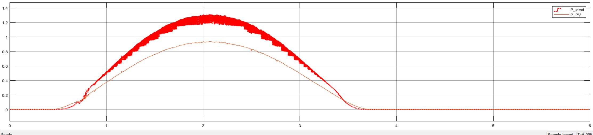

42
Other Parameters

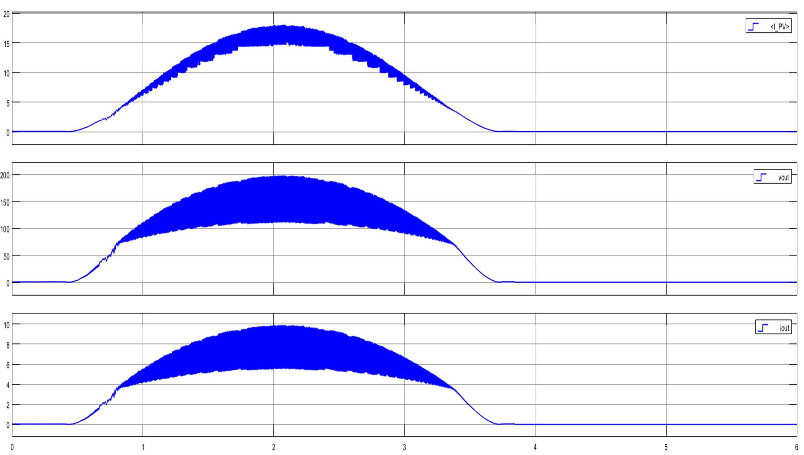

Current and Voltage Profile

Ideal power Vs Actual Power and Mean Efficiency Curve

43
Battery Control with bi-directional DC-DC Converter

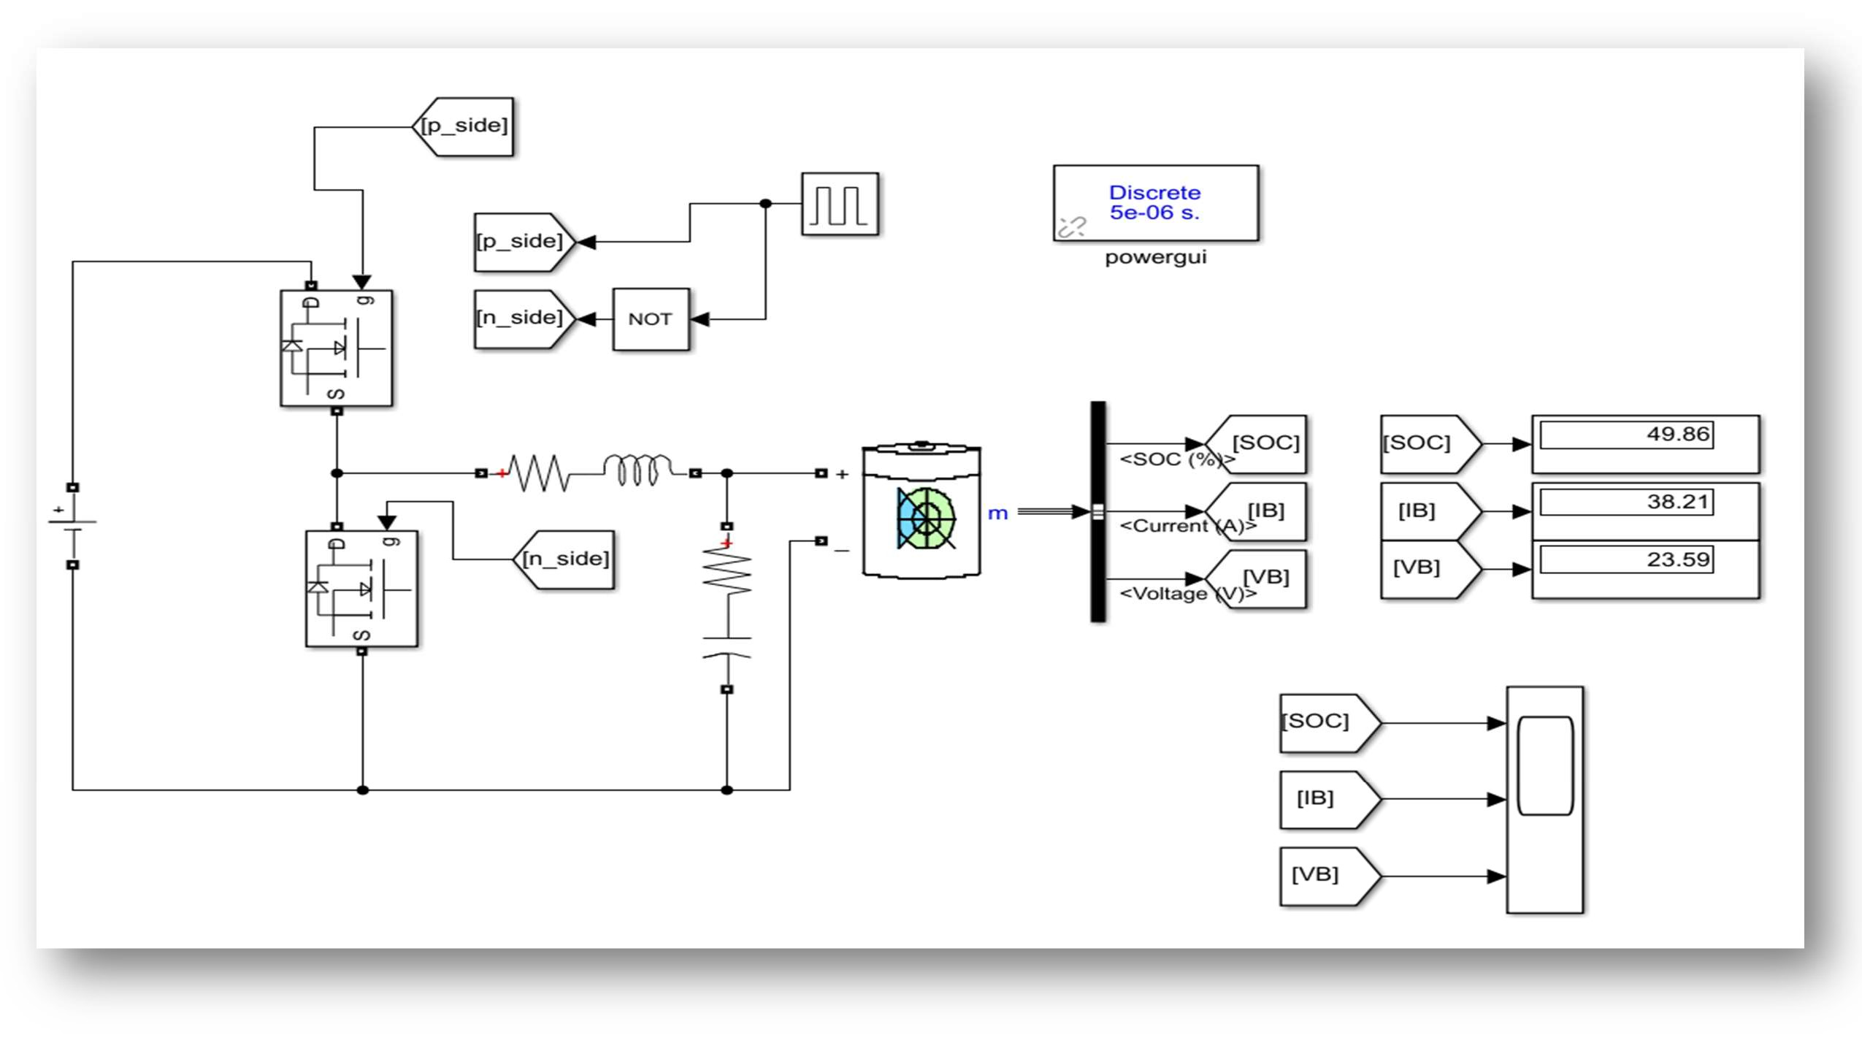

44
i) Without Converter-Charging State:

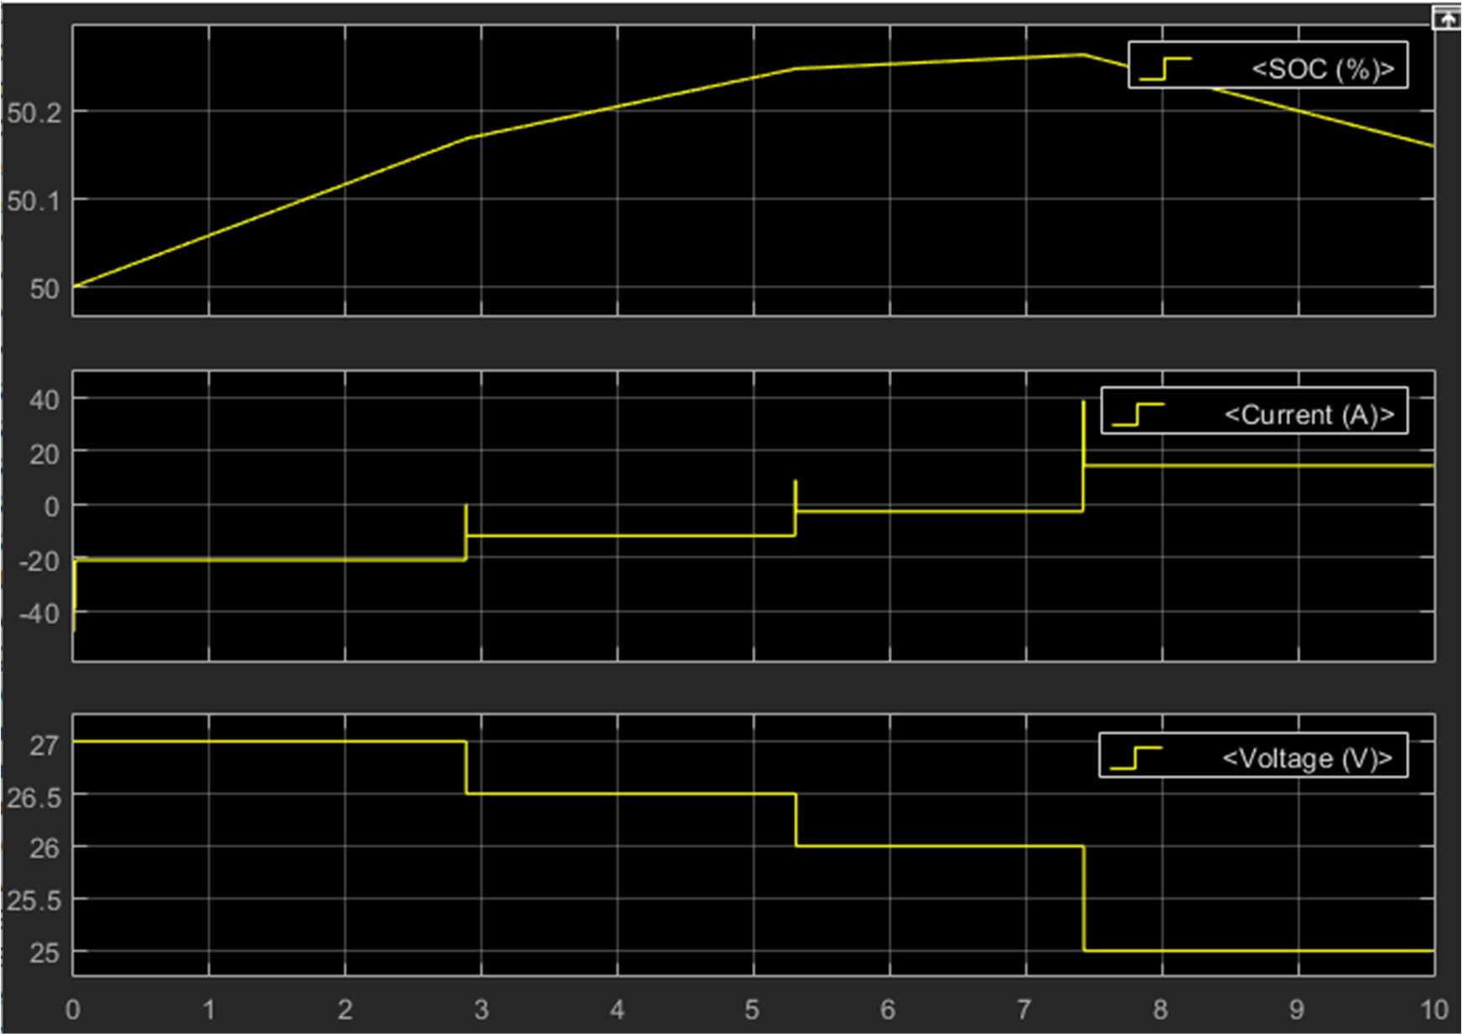

Discharging State:

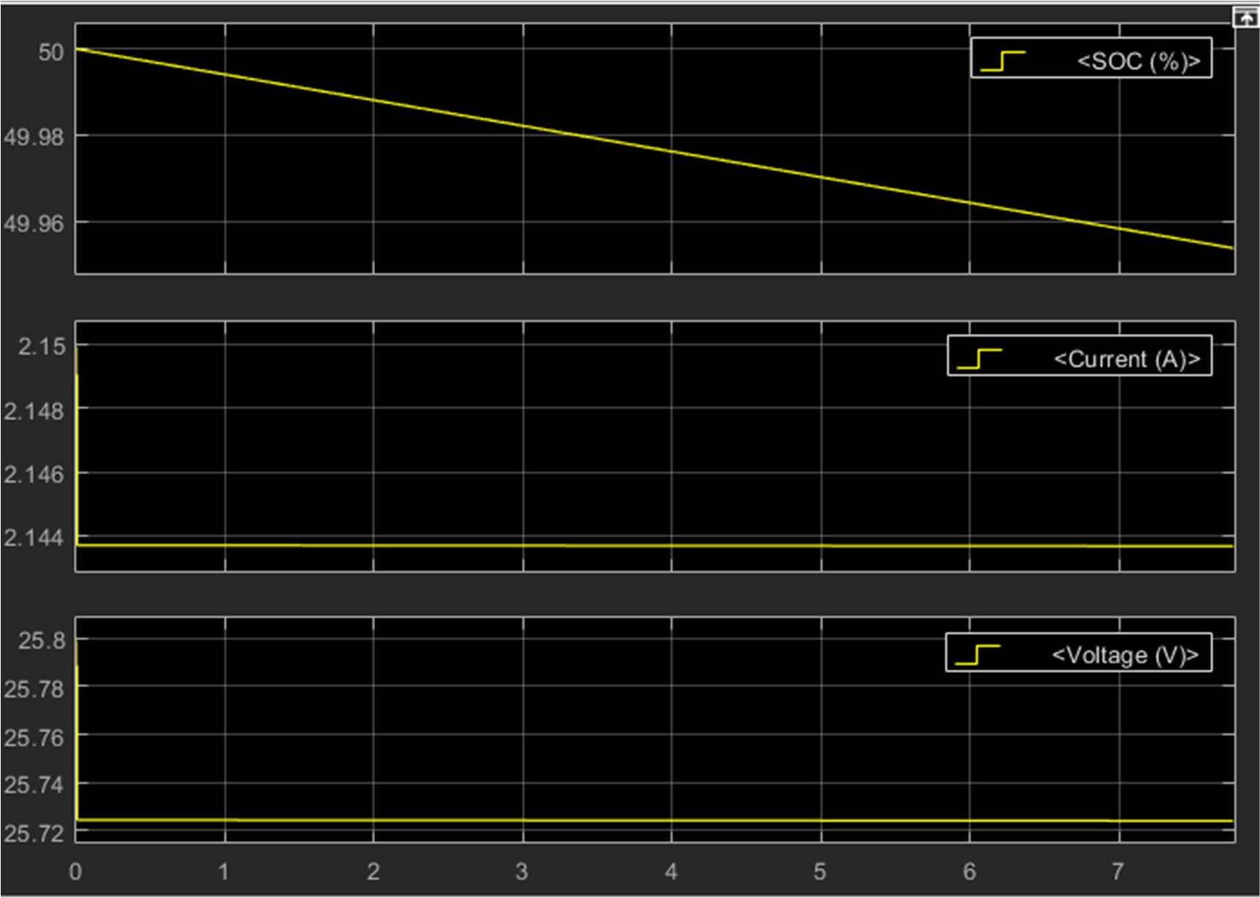

45
ii)With Converter

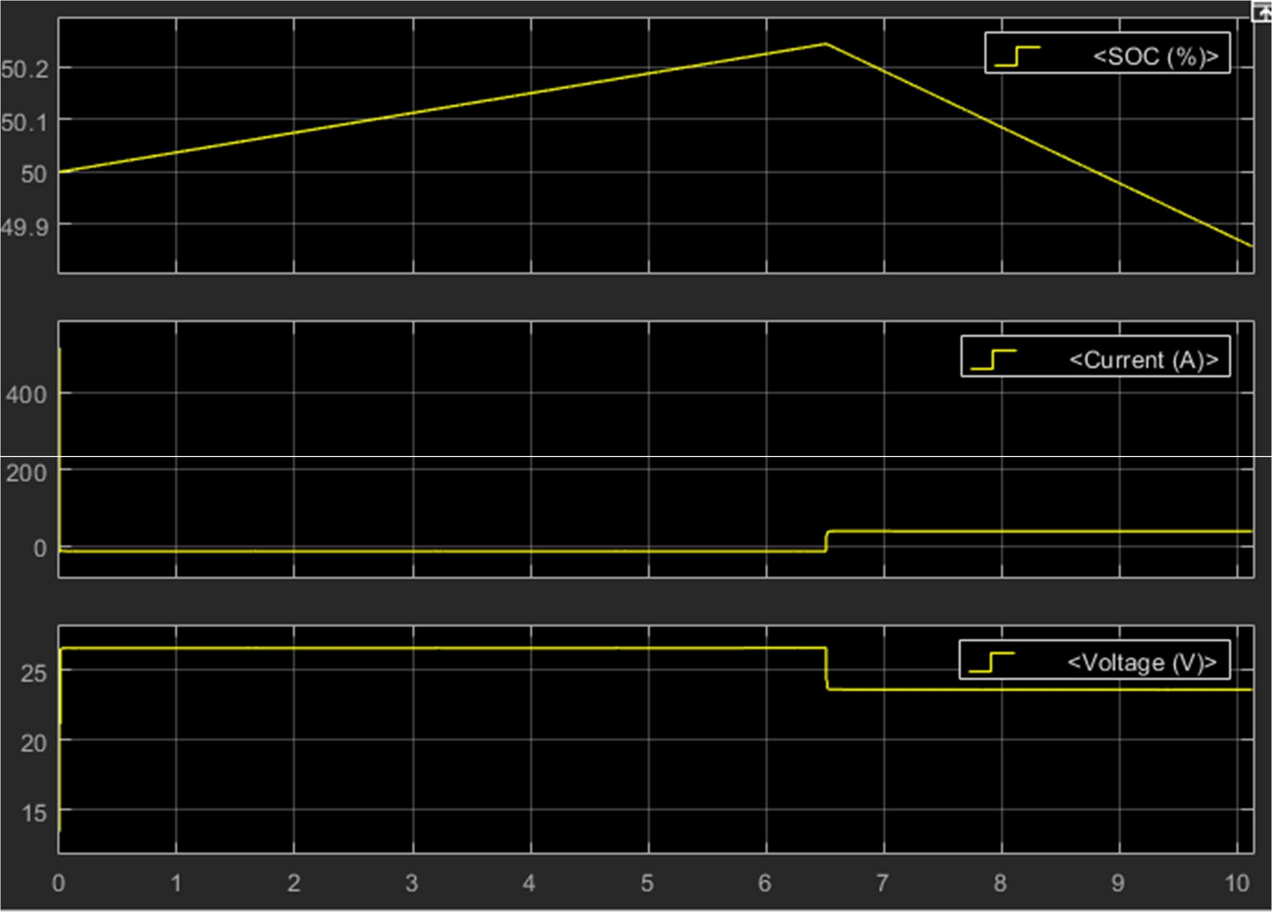

46
Integration of PV and Battery

➢ As stated in our title “Solar Battery Charger with MPPT tracking Scheme” we have already tracked the maximum power point in solar PV module. Now we are planning to integrate our solar pv with battery so that it can efficiently charge battery

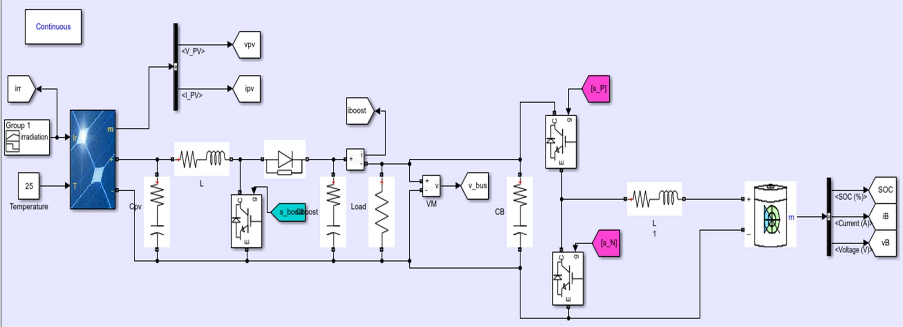

47

Plot of integration of Solar PV with Battery

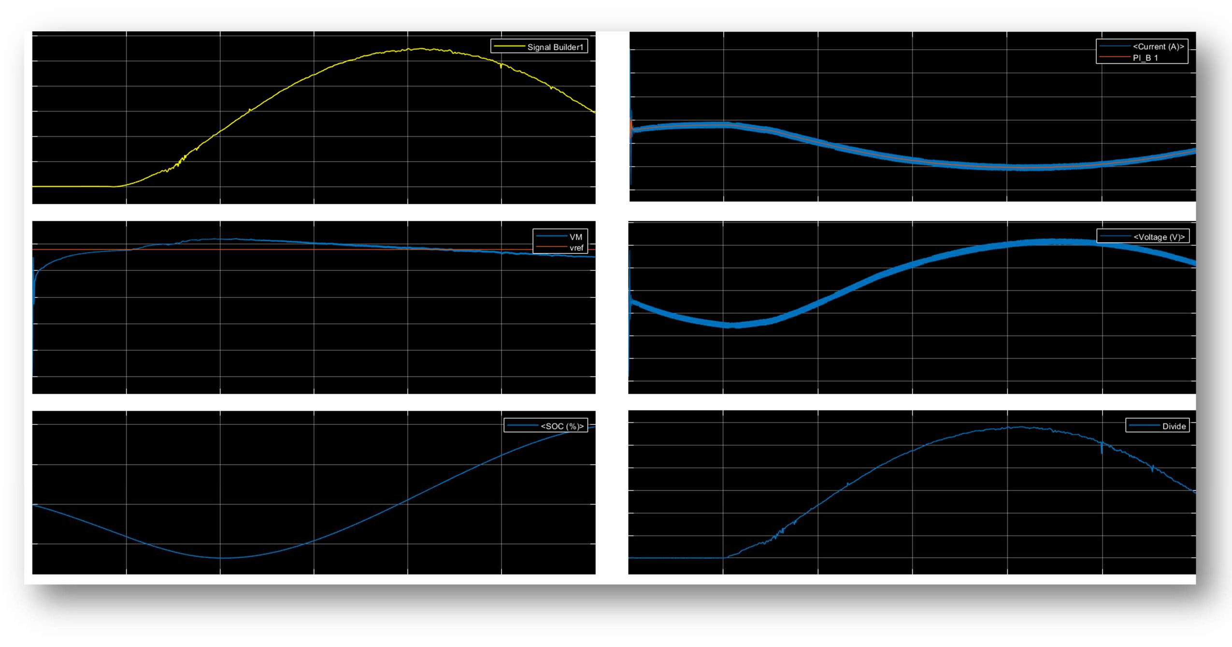

48
CONCLUSION

◆ This project presents simulated output of P&O algorithm using MATLAB-2018a software with boost converter as power conditioning unit and also results at constant duty cycle. The result also shows the effect of variation in temperature and irradiance on output power. Here, a solar based battery charging system is designed with MPPT algorithm.

◆ It is noticed that output power decreases with corresponding increase in cell temperature and decrease in irradiance level.

◆ The results were verified by comparing simulated results with theoretical calculations. The system is capable of tracking the PV module to get maximum available power.

◆ Battery charging is also controlled depending on SOC of battery.
Both controls are implemented using Boost converter.
References

◆ T. Esram, P.L. Chapman, "Comparison of Photovoltaic Array Maximum Power Point
Tracking Techniques," IEEE Transactions on Energy Conversion, vol. 22, no. 2, pp. 439-
449, June 2007.

◆ N. Femia, G. Petrone, G. Spagnuolo, M. Vitelli, "Optimizing sampling rate of P&O MPPT technique," in Proc. IEEE PESC, 2004, pp. 1945-1949.

◆ Aditi Bajpai and Arvind Mittal, “solar powered dc to dc buck-boost converter with mppt control, International Journal of Electronics, Electrical and Computational System. ISSN
2348-117X Volume 3, Issue 5 July 2014.

◆ Geoff Walker “Evaluating MPPT Converter topologies using a MATLAB PV module,” Journal of Electrical & Electronics Engg. Australia; Volume 21, Issue1:2001; 49-55

◆ N.Mohan, TM.Undeland, and WP.Robbins, “Power Electronics-Converters, Applications and Design,” John Wiley & Sons, Inc., NY,200

